CONTENT ANALYSIS: IDENTIFYING THE DOMAIN OF GIVEN CONTENT

PRACTICAL ASSIGNMENT REPORT
SUBMITTED TO

RAMAIAH INSTITUTE OF TECHNOLOGY
(Autonomous Institute, Affiliated to VTU)

Bangalore – 560054

SUBMITTED BY

Anurag P (1MS14CS019)
Sneha D (1MS14CS035)
Deepti B (1MS14CS039)
Tripti T (1MS14CS149)

As part of the Course Compiler Design – CS1561

SUPERVISED BY

Mrs. Parkavi A



DEPARTMENT OF COMPUTER SCIENCE AND ENGINEERING
RAMAIAH INSTITUTE OF TECHNOLOGY

Jan-May 2017
Department of Computer Science and Engineering
Ramaiah Institute of Technology
(Autonomous Institute, Affiliated to VTU)

Bangalore – 54

CERTIFICATE

This is to certify that Anurag P (1MS14CS019),D.Sneha (1MS14CS035),Deepti B (1MS14CS039) and Tripti T (1MS14CS149) have completed “ Content analysis : Identifying the domain of content ” as part of practical assignment.

We declare that the entire content embodied in this B.E. 6th Semester report contents are not copied.

Submitted by Guided by

1. Anurag P (1MS14CS019) Prof. Parkavi A
2. Sneha D (1MS14CS035)
3. Deepti B (1MS14CS039) (Assistant Professor, Dept. of CSE,RIT)
4. Tripti T (1MS14CS149)

(Dept of CSE, RIT)

Department of Computer Science and Engineering

Ramaiah Institute of Technology
(Autonomous Institute, Affiliated to VTU)

Bangalore – 54

EVALUATION SHEET

Sl. No | USN  Name | Content  and Demonstration  (5) | Speaking Skills  (1) | Teamwork  (1) | Neatness and care  (1) | Effectiveness  & Productivity (2) | Total Marks  (10)

Evaluated By

Name: Parkavi A
Designation: Assistant Professor
Department: Computer Science & Engineering, RIT
Signature:

HOD, CSE

CONTENTS

1. Abstract

2. Source Code

3. Result Snapshots

4. References

ABSTRACT

Unstructured text data, such as emails, blogs, contracts, academic publications, organizational documents, transcribed interviews, and even tweets, are important sources of data in Information Systems research. Various forms of qualitative analysis of the content of these data exist and have revealed important insights. Yet, to this date, these analyses have been hampered by limitations of human coding of large data sets, and by bias due to human interpretation.

In this paper, we compare and combine two quantitative analysis techniques to demonstrate the capabilities of computational analysis for content analysis of unstructured text. Specifically, we seek to demonstrate how two quantitative analytic methods, viz., Latent Semantic Analysis and data mining, can aid researchers in revealing core content topic areas in large (or small) data sets, and in visualizing how these concepts evolve, migrate, converge or diverge over time.

Through this work, we explore the capabilities of two computational techniques, and show how these techniques can be used to gather insights from a large corpus of unstructured text.
We have implemented our code using JavaScript.

SOURCE CODE

<!DOCTYPE html>
<style>
body {

padding: 40px;
overflow-x: hidden; /* For Opera */
-webkit-box-shadow:
inset #19d4ff 0 0 0 5px,
inset #18cdf7 0 0 0 1px,
inset #53dfff 0 0 0 10px,
inset #50d8f7 0 0 0 11px,
inset #8ce9ff 0 0 0 16px,
inset #88e2f7 0 0 0 17px,
inset #c5f4ff 0 0 0 22px,
inset #bfecf7 0 0 0 23px;
-moz-box-shadow:
inset #19d4ff 0 0 0 5px,
inset #18cdf7 0 0 0 1px,
inset #53dfff 0 0 0 10px,
inset #50d8f7 0 0 0 11px,
inset #8ce9ff 0 0 0 16px,
inset #88e2f7 0 0 0 17px,
inset #c5f4ff 0 0 0 22px,
inset #bfecf7 0 0 0 23px;
box-shadow:
inset #19d4ff 0 0 0 5px,
inset #18cdf7 0 0 0 1px,
inset #53dfff 0 0 0 10px,
inset #50d8f7 0 0 0 11px,
inset #8ce9ff 0 0 0 16px,
inset #88e2f7 0 0 0 17px,
inset #c5f4ff 0 0 0 22px,
inset #bfecf7 0 0 0 23px;

}

div{

font: bold 1.5em "Times New Roman", Times,serif ;
color: #C71585 ;

}

input[type="file"]{
border-top: 1px solid #ffffff;
background: #2e5c7a;
background: -webkit-gradient(linear, left top, left bottom, from(#598fb3), to(#2e5c7a));
background: -webkit-linear-gradient(top, #598fb3, #2e5c7a);
background: -moz-linear-gradient(top, #598fb3, #2e5c7a);
background: -ms-linear-gradient(top, #598fb3, #2e5c7a);
background: -o-linear-gradient(top, #598fb3, #2e5c7a);
padding: 11px 22px;
-webkit-border-radius: 9px;
-moz-border-radius: 9px;
border-radius: 9px;
-webkit-box-shadow: rgba(0,0,0,1) 0 1px 0;
-moz-box-shadow: rgba(0,0,0,1) 0 1px 0;
box-shadow: rgba(0,0,0,1) 0 1px 0;
text-shadow: rgba(0,0,0,.4) 0 1px 0;
color: #ffffff;
font-size: 16px;
font-family: 'Lucida Grande', Helvetica, Arial, Sans-Serif;
text-decoration: none;
vertical-align: middle;

}
input[type="file"]:hover{

border-top-color: #457391;
background: #457391;
color: #fafafa;

}

#jstext {
text-align: center;
font-size: 90px;
}

</style>
<center>
<body>
<div id="page-wrapper">

<h1> Domain Identification Compiler</h1>
<div>
Select a text file:
<br>

<input type="file" id="fileInput">

</div>
<pre id="fileDisplayArea"><pre>

<img src="2.jpg" style="width:600px;height:330px;">

</div>

<script>
console.clear();
window.onload = function() {

var fileInput = document.getElementById('fileInput');
var fileDisplayArea = document.getElementById('fileDisplayArea');

fileInput.addEventListener('change', function(e) {
var file = fileInput.files[0];
var textType = /text.*/;

if (file.type.match(textType)) {
var reader = new FileReader();

reader.onload = function(e)
{
fileDisplayArea.innerText = reader.result;
var a=reader.result;

var count=0,count1=0,count2=0,count3=0;

count = (a.match(/computer|science|cse|analytics|computers|system|compiler|artificial|machiene/g) || []).length;
count1 = (a.match(/assets|financial|capital|profit/g) || []).length;
count2 = (a.match(/data|mining|knowledge|algorithm|logic/g) || []).length;
count3 = (a.match(/Art|art|culture/g) || []).length;

if(count>=10)
{ document.writeln('<h1><center><font color="purple">'+count+'</font></center></h1>');
var text="Domain is Computer Science";
document.writeln('<h1><center><font color="purple">'+text+'</font></center></h1>');

}

if(count1>=10)
{ document.writeln('<h1><center><font color="purple">'+count1+'</font></center></h1>');
var text1="Domain is Finance";
document.writeln('<h1><center><font color="purple">'+text1+'</font></center></h1>');

}

if(count2>=10)
{ document.writeln('<h1><center><font color="purple">'+count2+'</font></center></h1>');
var text2="Domain is Data Mining"
document.writeln('<h1><center><font color="purple">'+text2+'</font></center></h1>');

}

if(count3>=10)
{ document.writeln('<h1><center><font color="purple">'+count3+'</font></center></h1>');
var text3="Domain is Art and Culture";
document.writeln('<h1><center><font color="purple">'+text3+'</font></center></h1>');

}

if(count1<10 && count2<10 && count3<10 && count<10){
var text4="Unknown Domain";
document.writeln('<h1><center><font color="purple">'+text4+'</font></center></h1>');

}

document.writeln('<br><br><h3><center><font color="black">'+a);

}
reader.readAsText(file);

}

else
{
fileDisplayArea.innerText = "File not supported!"
}

});
}

</script>
</body>
</center>
</html>

RESULT SNAPSHOTS

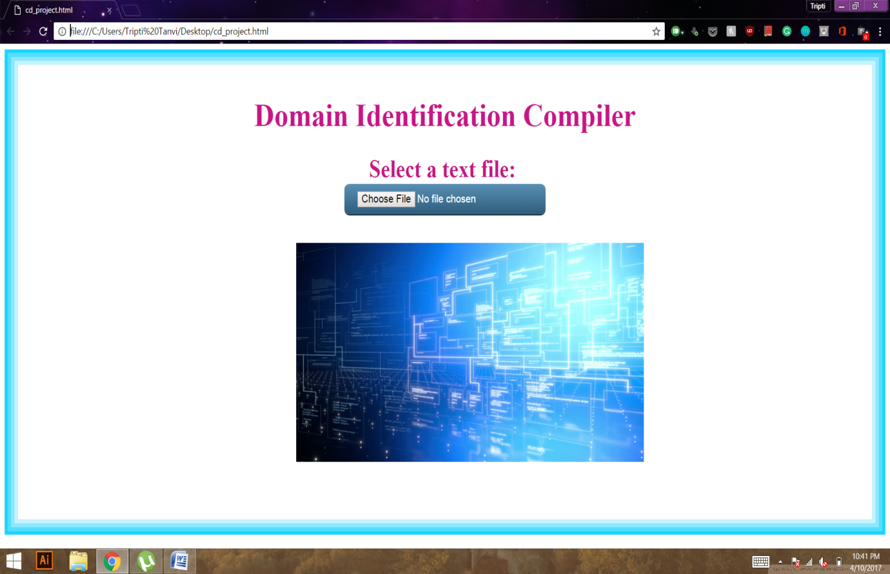

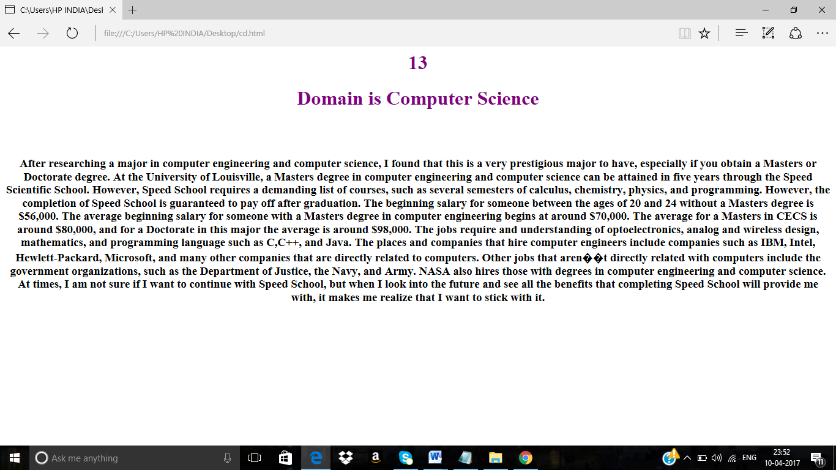

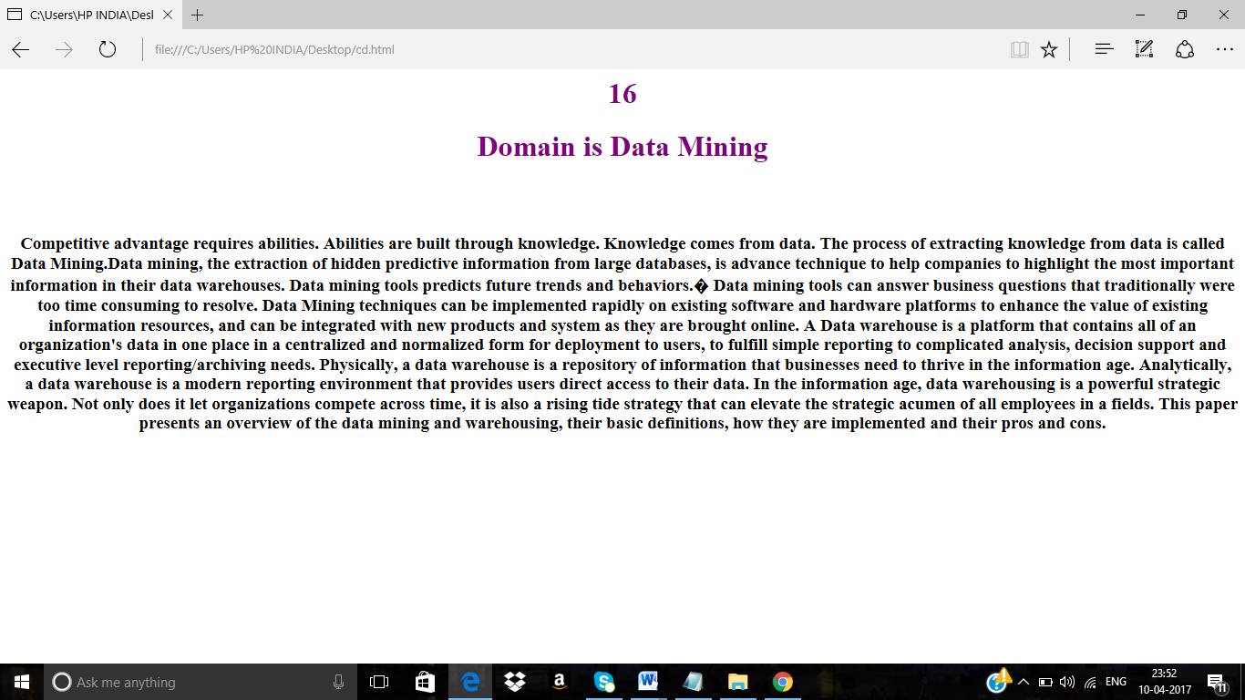

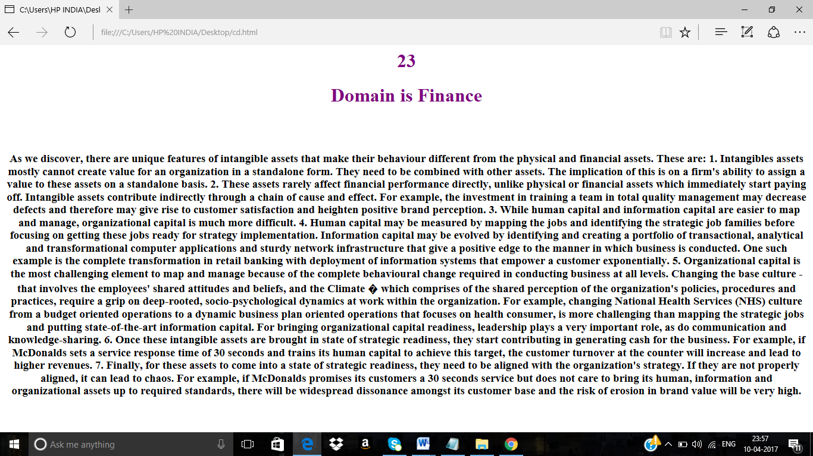

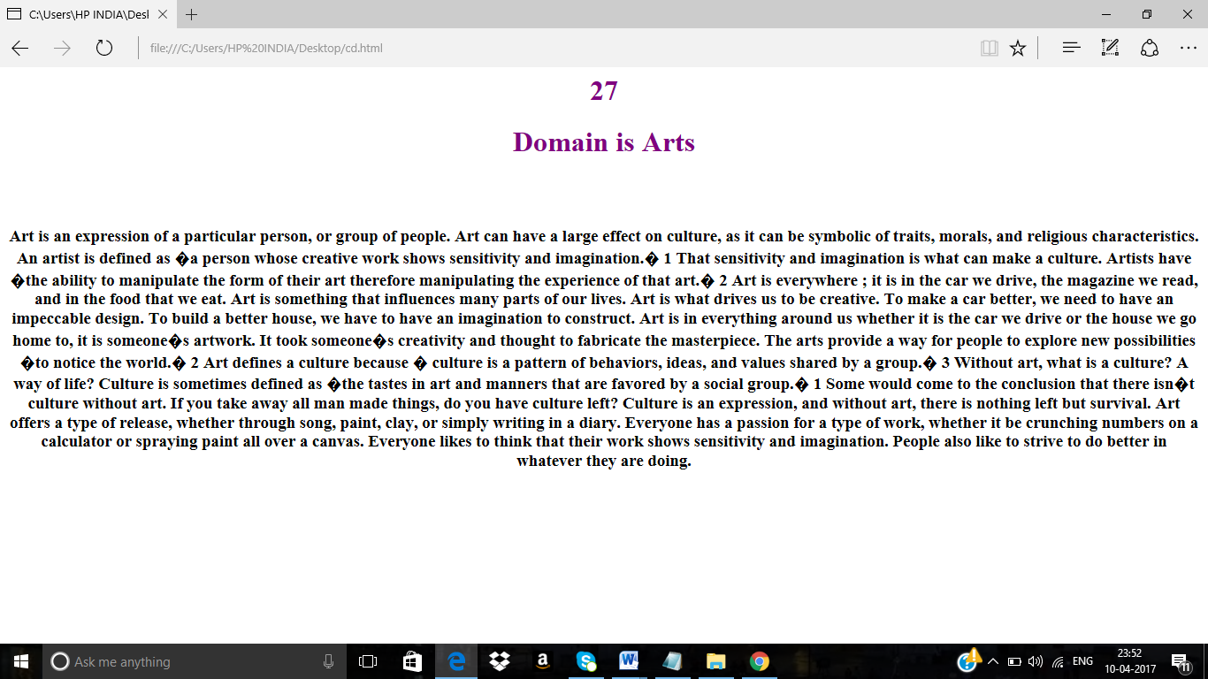

REFERENCES
- https://www.terry.uga.edu/management/contentanalysis/research/

- https://en.wikipedia.org/wiki/Content_analysis

